**Name: A. Shiva Surya Saran**

**Roll No.: BE-B 20**

**Artificial Intelligence & Robotics**

**Assignment 4**

**Unit 4: Natural Language Processing and ANN**

1. *Explain NLP and steps involved in natural language processing.*

Natural language processing (NLP) is a branch of artificial intelligence that helps computers understand, interpret, and manipulate human language. NLP helps computers communicate with humans in their own language and scales other language-related tasks. For example, NLP makes it possible for computers to read text, hear speech, interpret it, measure sentiment, and determine which parts are important.

NLP involves:

* **Text planning** − It includes retrieving the relevant content from knowledge base.
* **Sentence planning** − It includes choosing required words, forming meaningful phrases, setting tone of the sentence.
* **Text Realization** − It is mapping sentence plan into sentence structure.

Steps involved in NLP are:

* **Lexical Analysis** − It involves identifying and analyzing the structure of words. Lexicon of a language means the collection of words and phrases in a language. Lexical analysis is dividing the whole chunk of text into paragraphs, sentences, and words.
* **Syntactic Analysis (Parsing)** − It involves analysis of words in the sentence for grammar and arranging words in a manner that shows the relationship among the words.
* **Semantic Analysis** − It draws the exact meaning or the dictionary meaning from the text. The text is checked for meaningfulness. It is done by mapping syntactic structures and objects in the task domain.
* **Discourse Integration** − The meaning of any sentence depends upon the meaning of the sentence just before it. In addition, it also brings about the meaning of immediately succeeding sentence.
* **Pragmatic Analysis** − During this, what was said is re-interpreted on what it meant. It involves deriving those aspects of language which require real world knowledge.

1. *Explain Information Retrieval and its different models.*

An information retrieval system is a software programme that stores and manages information on documents, often textual documents but possibly multimedia. The system assists users in finding the information they need. It does not explicitly return information or answer questions. Instead, it informs on the existence and location of documents that might contain the desired information.

There are three basic processes an information retrieval system must support: the representation of the content of the documents, the representation of the user’s information need, and the comparison of the two representations.

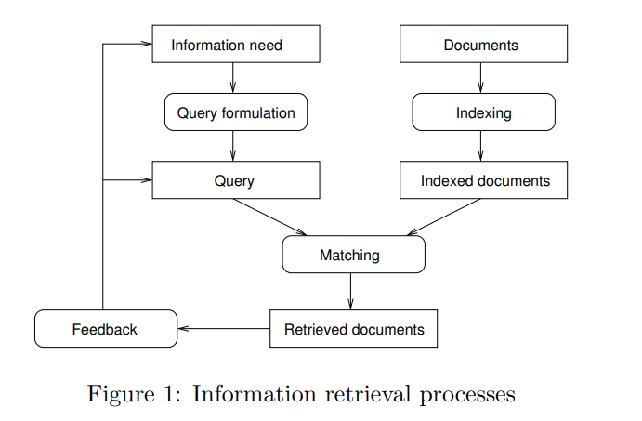

An information model (IR) model can be classified into the following three models −

***Classical IR Model***

It is the simplest and easy to implement IR model. This model is based on mathematical knowledge that was easily recognized and understood as well. Boolean, Vector and Probabilistic are the three classical IR models.

***Non-Classical IR Model***

It is completely opposite to classical IR model. Such kind of IR models are based on principles other than similarity, probability, Boolean operations. Information logic model, situation theory model and interaction models are the examples of non-classical IR model.

**Alternative IR Model**

It is the enhancement of classical IR model making use of some specific techniques from some other fields. Cluster model, fuzzy model, and latent semantic indexing (LSI) models are the example of alternative IR model.

1. *Enlist and explain different forms/types of learning.*

Learning is the process of converting experience into expertise or knowledge.

Learning can be broadly classified into three categories, as mentioned below, based on the nature of the learning data and interaction between the learner and the environment.

* Supervised Learning
* Unsupervised Learning
* Semi-supervised Learning

***Supervised Learning***

Supervised learning is commonly used in real world applications, such as face and speech recognition, products or movie recommendations, and sales forecasting. Supervised learning can be further classified into two types -

* Regression trains on and predicts a continuous-valued response, for example predicting real estate prices.
* Classification attempts to find the appropriate class label, such as analyzing positive/negative sentiment, male and female persons, benign and malignant tumors, secure and unsecure loans etc.

In supervised learning, learning data comes with description, labels, targets or desired outputs and the objective is to find a general rule that maps inputs to outputs. This kind of learning data is called labelled data. The learned rule is then used to label new data with unknown outputs.

Common examples of supervised learning include classifying e-mails into spam and not-spam categories, labelling webpages based on their content, and voice recognition.

***Unsupervised Learning***

Unsupervised learning is used to detect anomalies, outliers, such as fraud or defective equipment, or to group customers with similar behaviours for a sales campaign. It is the opposite of supervised learning. There is no labelled data here.

When learning data contains only some indications without any description or labels, it is up to the coder or to the algorithm to find the structure of the underlying data, to discover hidden patterns, or to determine how to describe the data. This kind of learning data is called unlabelled data.

Unsupervised learning algorithms are extremely powerful tools for analysing data and for identifying patterns and trends. They are most used for clustering similar input into logical groups. It includes Kmeans, Random Forests, Hierarchical clustering and so on.

***Semi-supervised Learning***

If some learning samples are labelled, but some other are not labelled, then it is semi-supervised learning. It makes use of a large amount of unlabelled data for training and a small amount of labelled data for testing. Semi-supervised learning is applied in cases where it is expensive to acquire a fully labelled dataset while more practical to label a small subset. For example, it often requires skilled experts to label certain remote sensing images, and lots of field experiments to locate oil at a particular location, while acquiring unlabelled data is relatively easy.

***Reinforcement Learning***

Here learning data gives feedback so that the system adjusts to dynamic conditions to achieve a certain objective. The system evaluates its performance based on the feedback responses and reacts accordingly. The best-known instances include self-driving cars and chess master algorithm AlphaGo.

1. *Explain the basic model of artificial neural network with its application.*

An artificial neural network (ANN) is the piece of a computing system designed to simulate the way the human brain analyses and processes information.

The idea of ANNs is based on the belief that working of human brain by making the right connections, can be imitated using silicon and wires as living neurons and dendrites.

An ANN has thousands of artificial neurons called processing units, which are interconnected by nodes. These processing units are made up of input and output units. The input units receive various forms and structures of information based on an internal weighting system, and the neural network attempts to learn about the information presented to produce one output report.

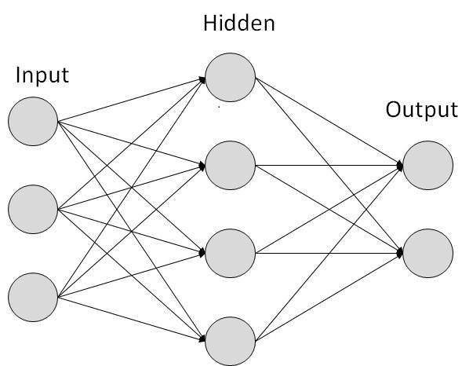

***Fig. ANN Model***

There are two Artificial Neural Network topologies

* Feedforward ANN  
  In this ANN, the information flow is unidirectional. A unit sends information to other unit from which it does not receive any information. There are no feedback loops. They are used in pattern generation/recognition/classification. They have fixed inputs and outputs.
* Feedback ANN  
  Feedback loops are allowed. They are used in content addressable memories.

***Applications of Artificial Neural Networks***

Email service providers use ANNs to detect and delete spam from a user’s inbox; asset managers use it to forecast the direction of a company’s stock; credit rating firms use it to improve their credit scoring methods; e-commerce platforms use it to personalize recommendations to their audience; chatbots are developed with ANNs for natural language processing; deep learning algorithms use ANN to predict the likelihood of an event; and the list of ANN incorporation goes on across multiple sectors, industries, and countries.

1. *Explain Reinforcement learning with an example and state its application.*

Reinforcement learning is the training of machine learning models to make a sequence of decisions. Here, an artificial intelligence faces a game-like situation. The computer employs trial and error to come up with a solution to the problem.

To get the machine to do what the programmer wants, the artificial intelligence gets either rewards or penalties for the actions it performs. Its goal is to maximize the total reward.

Although the designer sets the reward policy–that is, the rules of the game–he gives the model no hints or suggestions for how to solve the game. It is up to the model to figure out how to perform the task to maximize the reward, starting from totally random trials and finishing with sophisticated tactics and superhuman skills.

***How Reinforcement Learning works?***

Consider the scenario of teaching new tricks to your cat

* As cat does not understand English or any other human language, we cannot tell her directly what to do. Instead, we follow a different strategy.
* We emulate a situation, and the cat tries to respond in many ways. If the cat's response is the desired way, we will give her fish.
* Now whenever the cat is exposed to the same situation, the cat executes a similar action with even more enthusiastically in expectation of getting more reward(food).
* That is like learning that cat gets from "what to do" from positive experiences.
* At the same time, the cat also learns what not do when faced with negative experiences.

In this case,

* Your cat is an agent that is exposed to the environment. In this case, it is your house. An example of a state could be your cat sitting, and you use a specific word in for cat to walk.
* Our agent reacts by performing an action transition from one "state" to another "state."
* For example, your cat goes from sitting to walking.
* The reaction of an agent is an action, and the policy is a method of selecting an action given a state in expectation of better outcomes.
* After the transition, they may get a reward or penalty in return.

***Applications of Reinforcement Learning***

* Robotics for industrial automation.
* Business strategy planning
* Machine learning and data processing
* It helps you to create training systems that provide custom instruction and materials according to the requirement of students.
* Aircraft control and robot motion control